SIMATS ENGINEERING
ASSESSMENT TOOL 3
NAME: Danuspriyaa
REG NO: 192411182
COURSE NAME: INTERNET PROGRAMMING
COURSE CODE: CSA43

COURSE OUTCOME COVERED
CO-2 : Apply CSS layout and styling techniques to create visually appealing and responsive
web interfaces, and use JavaScript to enable interactive client-side behavior. (L3)
Assessment Tool : Short Answer Test
Weightage: 10%

QUESTIONS: Total Marks: 20

Question 1 (5 Marks)
Suppose that a company wants its website to work seamlessly on mobile, tablet, and desktop
devices. Explain the concept of responsive web design and its importance. Describe the key
CSS techniques used to achieve responsiveness, and explain how CSS Flexbox or Grid can
be used to design adaptive layouts. Illustrate your answer with a simple example layout and
suggest improvements to enhance user experience across different devices.
<!DOCTYPE html>
<html>
<head>
<meta charset="UTF-8">
<title>Responsive Web Design</title>

<style>
*{
margin:0;
padding:0;
box-sizing:border-box;
font-family:Arial,sans-serif;
}

body{
background:#f4f4f4;
}

header{
background:#0077cc;
color:white;
padding:20px;
text-align:center;
}

.container{
display:flex;
gap:20px;
padding:20px;
}

.box{
flex:1;
background:white;
padding:20px;
text-align:center;
border-radius:8px;
box-shadow:0 0 5px gray;
}

footer{
background:#333;
color:white;
text-align:center;
padding:15px;
}

@media(max-width:768px){
.container{
flex-direction:column;
}
}
</style>

</head>
<body>

<header>
<h1>Responsive Website</h1>
</header>

<div class="container">
<div class="box">
<h2>Mobile</h2>
<p>Responsive layout adapts automatically.</p>
</div>

<div class="box">
<h2>Tablet</h2>
<p>Flexbox creates flexible columns.</p>
</div>

<div class="box">
<h2>Desktop</h2>
<p>Media queries adjust layout.</p>
</div>
</div>

<footer>
Responsive Design using Flexbox
</footer>

</body>
</html>
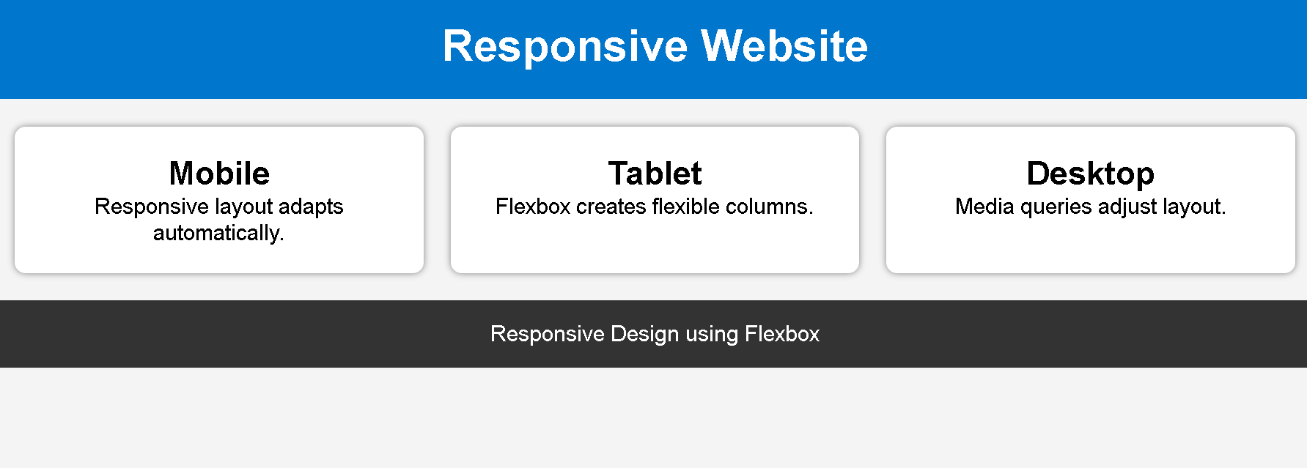
Question 2 (5 Marks)
Suppose that a webpage contains a form where user input must be validated before
submission. Explain the concept of client-side validation and its purpose. Describe how
JavaScript event handling is used in validation and explain the role of regular expressions in
validating inputs such as email or phone numbers. Provide a suitable example and suggest
improvements for better usability and security.
<!DOCTYPE html>
<html>
<head>
<meta charset="UTF-8">
<title>Client Side Validation</title>

<style>
body{
font-family:Arial;
background:#f2f2f2;
}

.container{
width:350px;
margin:50px auto;
background:white;
padding:20px;
border-radius:10px;
box-shadow:0 0 10px gray;
}

input{
width:100%;
padding:10px;
margin:10px 0;
}

button{
width:100%;
padding:10px;
background:#0077cc;
color:white;
border:none;
cursor:pointer;
}

button:hover{
background:#005fa3;
}

p{
color:red;
}
</style>

</head>
<body>

<div class="container">

<h2>Registration Form</h2>

<form onsubmit="return validateForm()">

<input type="text" id="email" placeholder="Enter Email">

<input type="text" id="phone" placeholder="Enter Phone Number">

<button type="submit">Submit</button>

<p id="msg"></p>

</form>

</div>

<script>

function validateForm(){

let email=document.getElementById("email").value;
let phone=document.getElementById("phone").value;

let emailPattern=/^[^ ]+@[^ ]+\.[a-z]{2,3}$/;
let phonePattern=/^[0-9]{10}$/;

if(!email.match(emailPattern)){
document.getElementById("msg").innerHTML="Invalid Email";
return false;
}

if(!phone.match(phonePattern)){
document.getElementById("msg").innerHTML="Invalid Phone Number";
return false;
}

alert("Form Submitted Successfully");
return true;

}

</script>

</body>
</html>
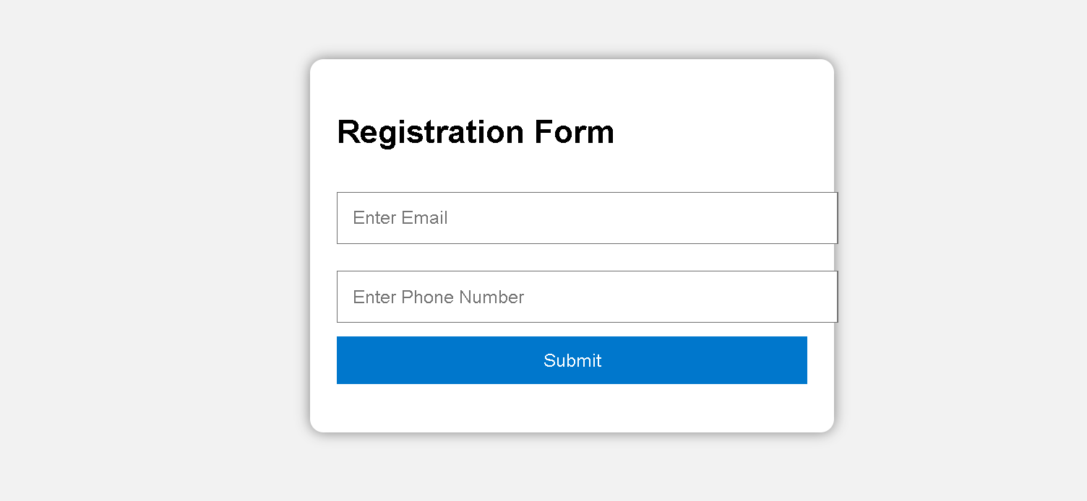

Question 3 (5 Marks)
Suppose that a webpage layout breaks when the browser window is resized. Explain the CSS
box model and its components, and describe how CSS positioning techniques affect layout
structure. Identify possible causes of layout breaking and explain how media queries can be
used to resolve these issues. Suggest best practices to ensure a stable and responsive layout.
<!DOCTYPE html>
<html>
<head>
<meta charset="UTF-8">
<title>CSS Box Model</title>

<style>

*{
box-sizing:border-box;
}

body{
margin:0;
font-family:Arial;
background:#eeeeee;
}

.container{
display:flex;
padding:20px;
gap:20px;
}

.box{
background:white;
border:5px solid blue;
padding:20px;
margin:10px;
flex:1;
text-align:center;
}

@media(max-width:700px){

.container{
flex-direction:column;
}

}

</style>

</head>

<body>

<h2 style="text-align:center;padding:20px;">
CSS Box Model Example
</h2>

<div class="container">

<div class="box">
<h3>Content</h3>
<p>Padding, Border and Margin are visible.</p>
</div>

<div class="box">
<h3>Responsive</h3>
<p>Media Query changes layout.</p>
</div>

</div>

</body>
</html>
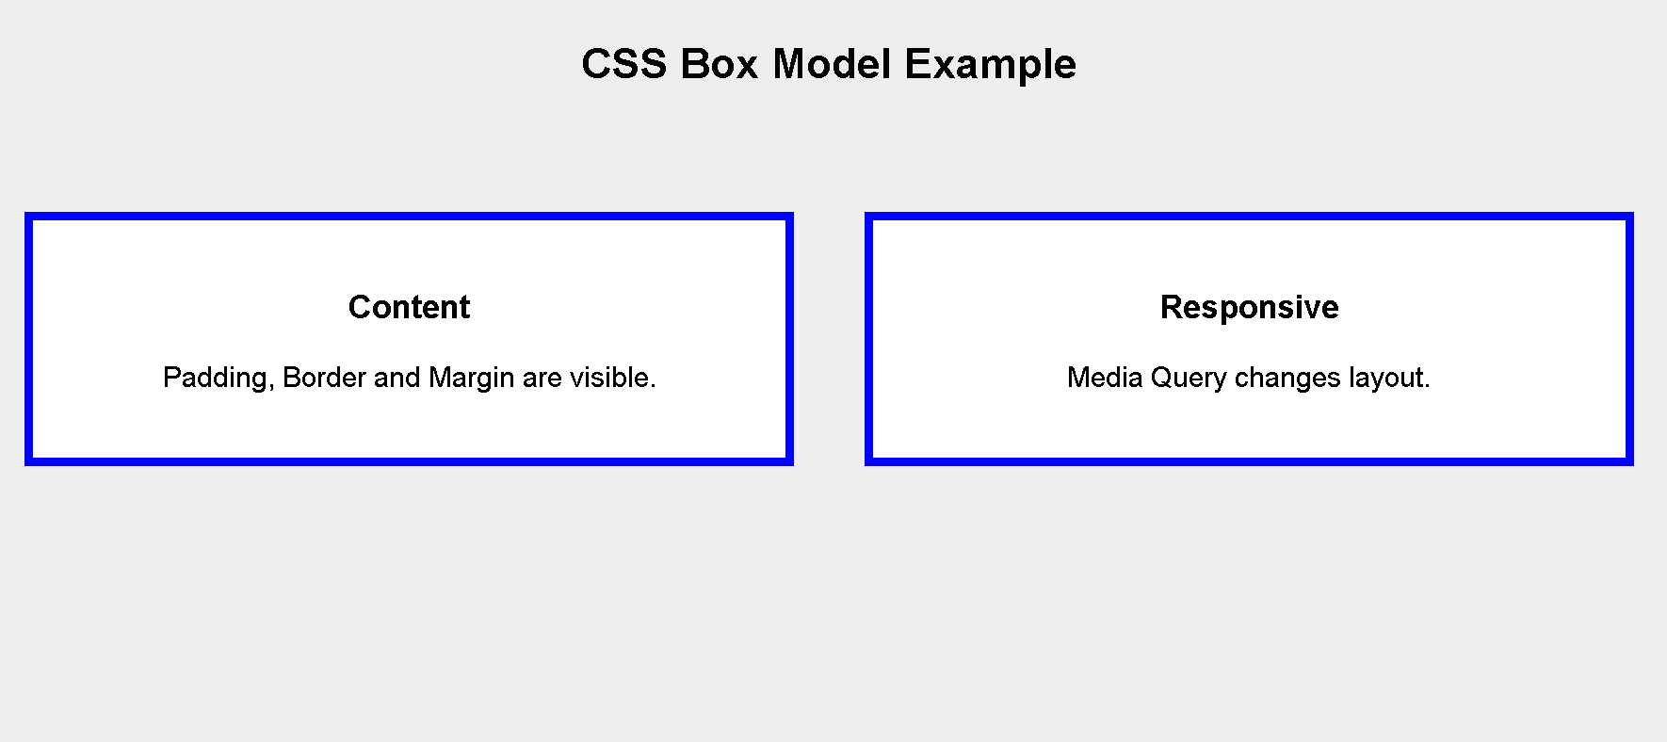
Question 4 (5 Marks)
Suppose that a website requires dynamic content updates without reloading the entire page.
Explain the concept of the Document Object Model (DOM) and its role in web development.
Describe how JavaScript can be used to manipulate the DOM for updating webpage content
dynamically. Provide an example and suggest improvements to enhance performance and
user experience.
<!DOCTYPE html>
<html>
<head>

<meta charset="UTF-8">

<title>DOM Example</title>

<style>

body{
font-family:Arial;
background:#f2f2f2;
text-align:center;
padding-top:100px;
}

.container{
background:white;
width:350px;
margin:auto;
padding:20px;
border-radius:10px;
box-shadow:0 0 10px gray;
}

button{
padding:10px 20px;
background:#0077cc;
color:white;
border:none;
cursor:pointer;
margin-top:20px;
}

button:hover{
background:#005fa3;
}

</style>

</head>

<body>

<div class="container">

<h2 id="title">
Welcome to Internet Programming
</h2>

<button onclick="changeText()">
Update Content
</button>

</div>

<script>

function changeText(){

document.getElementById("title").innerHTML="Content Updated Successfully!";

}

</script>

</body>
</html>
